HANOI UNIVERSITY OF SCIENCE AND TECHNOLOGY

School of Information and communications technology

Software Requirement Specification

Version 1.0

**EcoBikeRental**

Subject: IT Software Development

**Group 10**

Vu Trung Dung

Nguyen Xuan Hoang

Nguyen Trung Nghia

Nguyen Ngoc Quy

*Hanoi, 10/2020*

# Table of contents

Table of contents 2

1 Introduction 3

1.1 Objective 3

1.2 Scope 3

1.3 Glossary 3

1.4 References 3

2 Overall Description 4

2.1 Actors 4

2.2 Use case diagrams 4

2.3 Business processes 4

3 Detailed Requirements 4

3.1 Use case specification for “Renting Bikes” 5

3.2 Use case specification for “Choose Payment Method” 6

3.3 Use case specification for “Deduct money” 6

3.4 Use case specification for “Return Bikes” 6

3.5 Use case specification for “Return Deposit Money” 6

3.6 Use case specification for “View Rented Bikes Information” 6

3.7 Use case specification for “View All Bikes In Station” 6

3.8 Use case specification for “View Bike Details” 6

3.9 Use case specification for “View All Dock Stations” 6

4 Supplementary specification 8

4.1 Functionality 8

4.2 Usability 8

4.3 Reliability 8

4.4 Performance 8

4.5 Supportability 8

4.6 Other requirements 8

# Introduction

## 1.1. Objective

The purpose of this document is to present a detailed description of the Eco Bike Rental system. It will explain the purpose and features of the system, the interfaces of the system, what the system will do, the constraints under which it must operate and how the system will react to external stimuli. This document is intended for both the stakeholders and the developers of the system and will be proposed to the Eco Park Township Management Department for its approval.

## 1.2. Scope

This software system will be a Eco Park Bike Rental System for everyone including novice users to use without any training. This system will be designed to allow for approximately 100 average concurrent users with no perceivable performance difference and can be operated upto 200 hours continuously. The system is also very responsive with typical response time around 1 second and only requires 2 hours of downtime for maintenance.

## 1.3. Glossary

|  |  |
| --- | --- |
| **Term** | **Definition** |
| User | Main actor of the system |
| Map | The entire area of Eco Park, with detailed location of all docking stations |
| Docking station | The area to store all bikes available to the user |
| E-bike | Standard bike with an integrated electric motor for assisted propulsion |
| Twin bike | Standard bike with 2 saddles, 2 pedal and no electric motor |

## 1.4. References

* IEEE. IEEE Std 830–1998 IEEE Recommended Practice for Software Requirements Specifications. IEEE Computer Society, 1998.
* [IEEE] The applicable IEEE standards are published in “IEEE Standards Collection,” 2001 edition.
* [Bruade] The principal source of textbook material is “Software Engineering: An Object-Oriented Perspective” by Eric J. Bruade (Wiley 2001).
* [Reaves SPMP] “Software Project Management Plan Jacksonville State University of Computing and Information Sciences Web Accessible Alumni Database.” Jacksonville State University, 2003.

# Overall Description

## 2.1. Actors

There are 2 main actors in the system: Customer and Interbank.

## 2.2. Use case diagrams

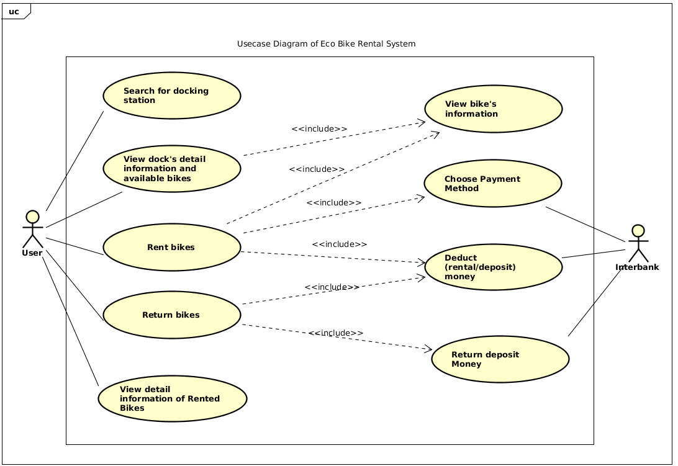

## 2.3. Business processes

In our EcoBike System, we will have the general business processes for renting bike as following diagram:

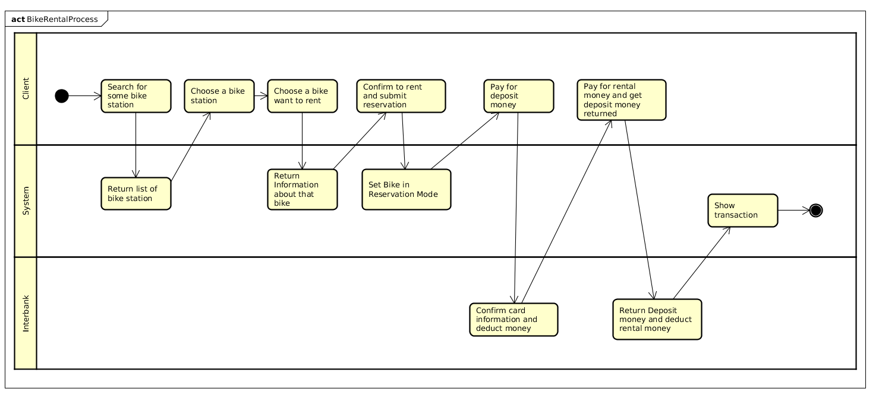

# Detailed Requirements

## 3.1. Use case specification for “Renting Bikes”

### 3.1.1. Use case code

UC001

### 3.1.2. Brief description

This user case describes the interaction between Customer and Software when Customer wishes to rent a bike

### 3.1.3. Actors

* Customer

### 3.1.4. Preconditions

None

### 3.1.5. Basic flow of events

Step 1. Customer enter the barcode and request to rent a bike

Step 2. Software validates the barcode

Step 3. Software forwards to View bikes’s information Use Case

Step 4. Software forwards to choose Payment Method Use Case

Step 5. Software calculates the renting price and asks Customer to confirm

Step 6. Customer confirms the transactions

Step 7. Software forwards to Deduct money Use Case

Step 8. Software saves the transactions

Step 9. Software unlocks the locker, allow customer to use the bike

Step 10. Shows the successful renting message

### 3.1.6. Alternative flows

Table 1-Alternative flows of events for UC Renting Bikes

|  |  |  |  |  |
| --- | --- | --- | --- | --- |
| **No** | **Location** | **Condition** | **Action** | **Resume location** |
|  | At Step 2 | If the barcode which customer entered is invalid or bike is already in use | * Notify invalid barcode or the bike is unavailable to Customer | Resumes at Step 1 |
|  | At Step 6 | If Customer cancel the confirmation | * Cancel all the transactions * Notify that all transactions was cancels | Use case ends |

### 3.1.7. Activity diagrams

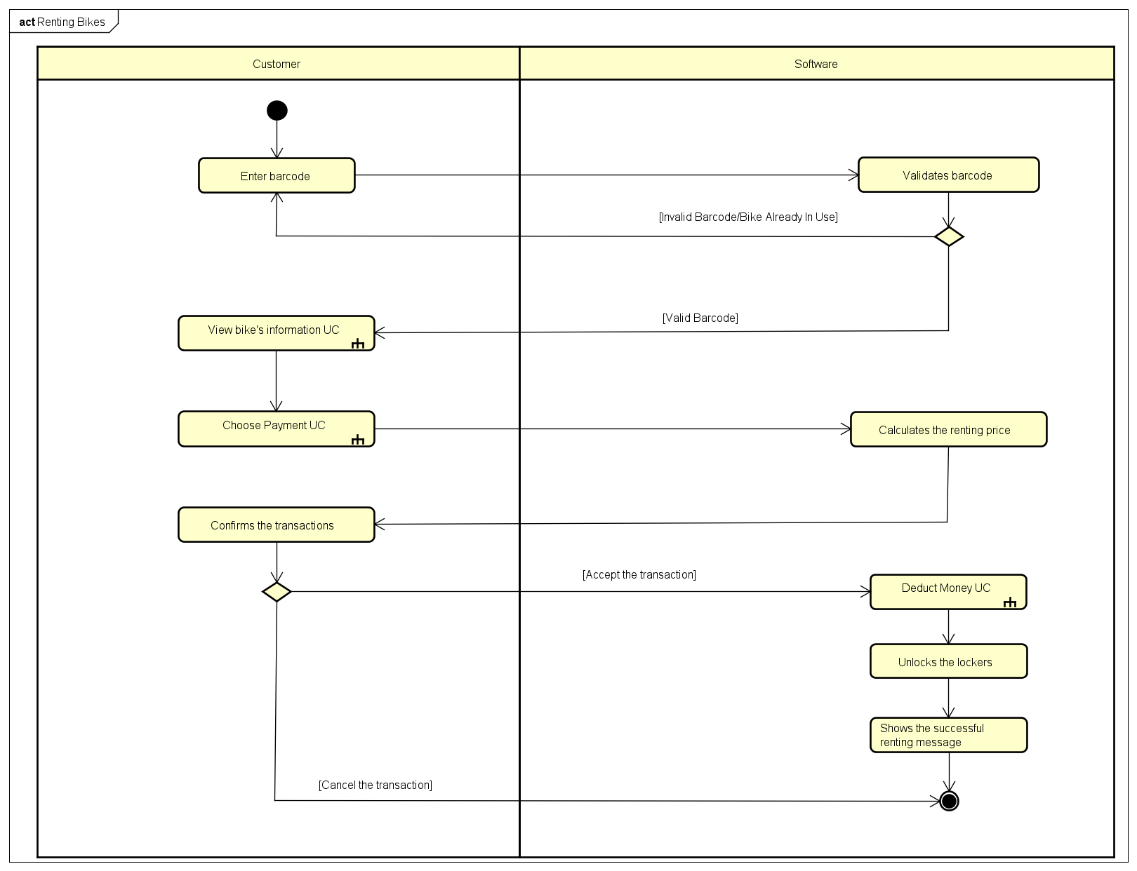

### 3.1.8. Input data

Table 2-Input data of Barcode

|  |  |  |  |  |  |
| --- | --- | --- | --- | --- | --- |
| **No** | **Data fields** | **Description** | **Mandatory** | **Valid condition** | **Example** |
| 1. 1. | Barcode |  | Yes |  | 4fy7tvi7 |

### 3.1.9 Output data

Table 3-Output data of Transaction Status

|  |  |  |  |  |
| --- | --- | --- | --- | --- |
| **No** | **Data fields** | **Description** | **Display format** | **Example** |
| 1 | Transaction id | The id of the transactions which customer paid for renting |  | ID121 |
| 2 | Start Time | Time when customer start renting | Hh:mm dd/mm/yyyy | 09:00 19/09/2020 |
| 3 | Deposit | Amount of money which customer paid for renting | - Comma for thousands  separator  - Positive integer  - Right alignment | 430,000 |
| 4 | Barcode of the rented bike |  |  | 4fy7tvi7 |

### 3.1.10. Post conditions

None

## 3.2. Use case specification for “Choose Payment Method”

### 3.2.1. Use case code

UC002

### 3.2.2. Brief Description

This user case describes the interaction between Customer, Software and Interbank when customer wishes to choose a payment method.

### 3.2.3. Actors

* Customer
* Interbank

### 3.2.4. Preconditions

Customer had logged in

### 3.2.5. Basic Flow of Events

Step 1. Customer choose payment methods and payment information

Step 2. Software call Validating Information API

Step 3. Interbank validates payment information and sends status to Software

Step 4. Software returns result to customer

### 3.2.6. Alternative flows

Table 4-Alternative flows of events for UC Choose Payment Method

|  |  |  |  |  |
| --- | --- | --- | --- | --- |
| **No** | **Location** | **Condition** | **Action** | **Resume location** |
| 1. 1. | At Step 3 | Error when validating payment information | * Sends the failure message to Software * Notify that wrong payment method to customer | The use case ends |

### 3.2.7. Activity diagrams

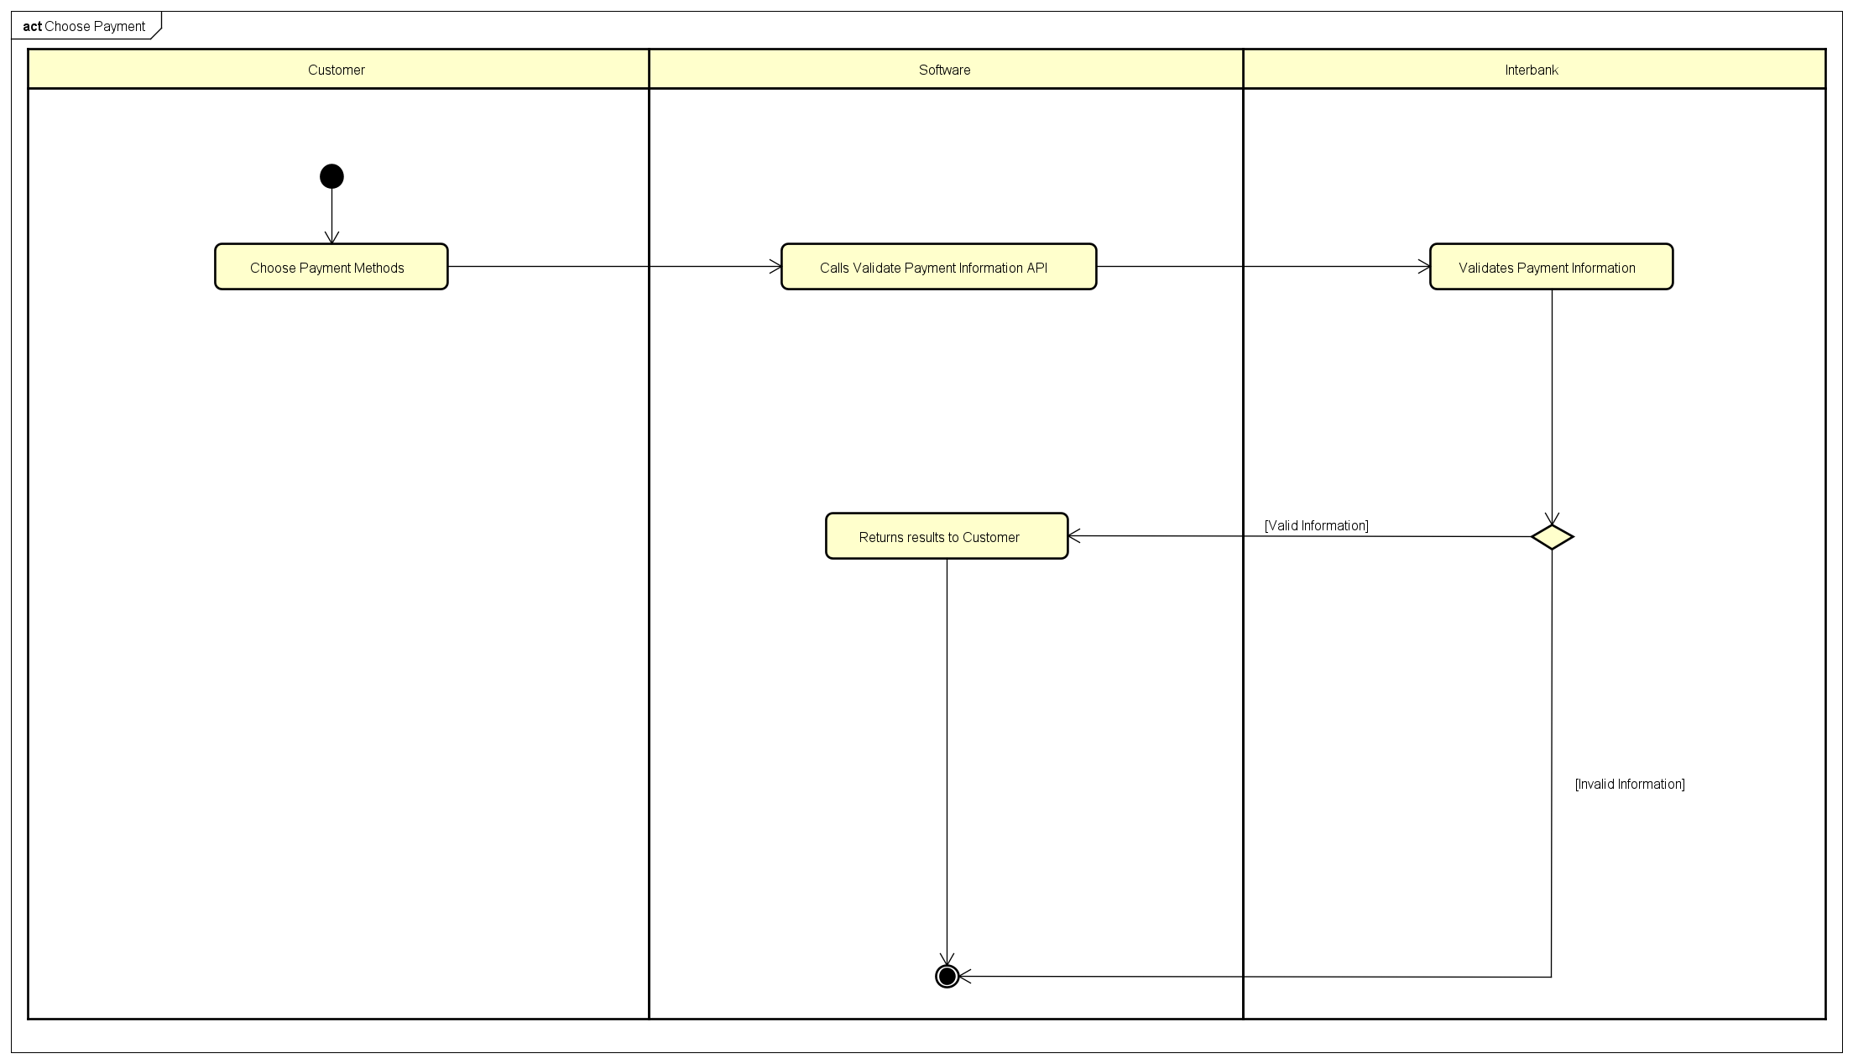

### 3.2.8. Input data

Table 5-Input data of payment information

|  |  |  |  |  |  |
| --- | --- | --- | --- | --- | --- |
| **No** | **Data fields** | **Description** | **Mandatory** | **Valid condition** | **Example** |
| 1. 1. | Bank’s Name | Choose from a list | Yes |  | Vietcombank |
| 2. | Card’s Number |  | Yes |  | 4283 1001 2345 6789 |
| 3. | Cardholder Name |  | Yes |  | Nguyen Xuan Hoang |
| 4. | Card expire Date |  | Yes | Time in future | 12/22 |

### 3.2.9. Output data

None

### 3.2.10. Postconditions

None

## 3.3. Use case specification for “Deduct money”

### 3.3.1. Use case code

UC003

### 3.3.2. Brief Description

This use case can be included whenever the software needs to deduct an amount of money from the user by using the interbank API.

### 3.3.3. Actors

* Customer

### 3.3.4. Preconditions

None

### 3.3.5. Basic Flow of Events

Step 1. The software calls check account API

Step 2. The interbank return the balance on the customer’s credit card

Step 3. The software compares amount of money need to deduct with the balance

Step 4. The software call “deduct money” API

Step 5. The interbank deduct money from customer’s account

Step 6. The software returns status of transactions

### 3.3.6. Alternative flows

Table N-Alternative flows of events for UC Deduct Money

|  |  |  |  |  |
| --- | --- | --- | --- | --- |
| **No** | **Location** | **Condition** | **Action** | **Resume location** |
|  | At Step 2 | InterbankError | * Sends the failure message to Software | The use case ends |
|  | At Step 3 | If not enough money for renting | * Sends the failure message to software | Use case ends |
| 3.. | At step 5 | Interbank Error | * Sends the failure message to software | The use case ends |

### 3.3.7. Activity diagrams

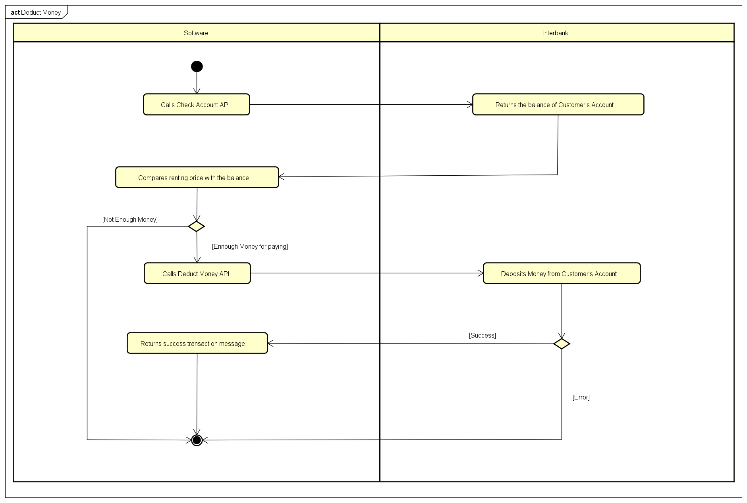

### 3.3.8. Input data

Table A- Input data for calling deduct money API

|  |  |  |  |  |  |
| --- | --- | --- | --- | --- | --- |
| **No** | **Data fields** | **Description** | **Mandatory** | **Valid condition** | **Example** |
| 1. 1. | Current balance |  | Yes | Must not contain words |  |
| 2. | Account number |  | Yes | Must not contain words |  |
| 3. | Bank’s name | Choose from a list | Yes |  |  |

### 3.3.9. Output data

|  |  |  |  |  |
| --- | --- | --- | --- | --- |
| **No** | **Data fields** | **Description** | **Display format** | **Example** |
| 1 | Owner’s balance | Balance | - Number, separated comma for big number | 2,000,000 VND |
| 2 | deduct amount | Amount of deducted money | - Number, separated comma for big number | 2,000,000  VND |
| 3 | Transaction status | status | - Success or failed | Successfully transaction |
| 4 | Card’s owner information( owner’s name, …) | Information of card’s owner | - Words | 12310243324  Nguyen Trung Nghia |

### 3.3.10. Postconditions

None

## 3.4. Use case specification for “Return Bikes”

### 3.4.1. Use case code

UC004

### 3.4.2. Brief Description

This Use case describes the interaction between Customer and EcoBikeRental System where Customers wish to return their bike which they had already rented before.

### 3.4.3. Actors

* Customer
* Interbank

### 3.4.4. Preconditions

Customers had already rented bikes in EcoBikeRental System

### 3.4.5. Basic Flow of Events

Step 1. The customer requests to return bikes.

Step 2. The software sends the rental bike information.

Step 3. The customer chooses an available dock station.

Step 4. The software validates the chosen dock station’s status.

Step 5. The software forwards to Return Deposit Money Use Case.

Step 6. The software forwards to Deduct Money Use Case.

Step 7. The software shows and saves rental transactions

### 3.4.6. Alternative flows

Table N-Alternative flows of events for UC Return Bike

|  |  |  |  |  |
| --- | --- | --- | --- | --- |
| **No** | **Location** | **Condition** | **Action** | **Resume location** |
|  | At Step 2 | If the barcode was invalid | * Notifies barcode error to customer | The use case ends |

### 3.4.7. Activity diagrams

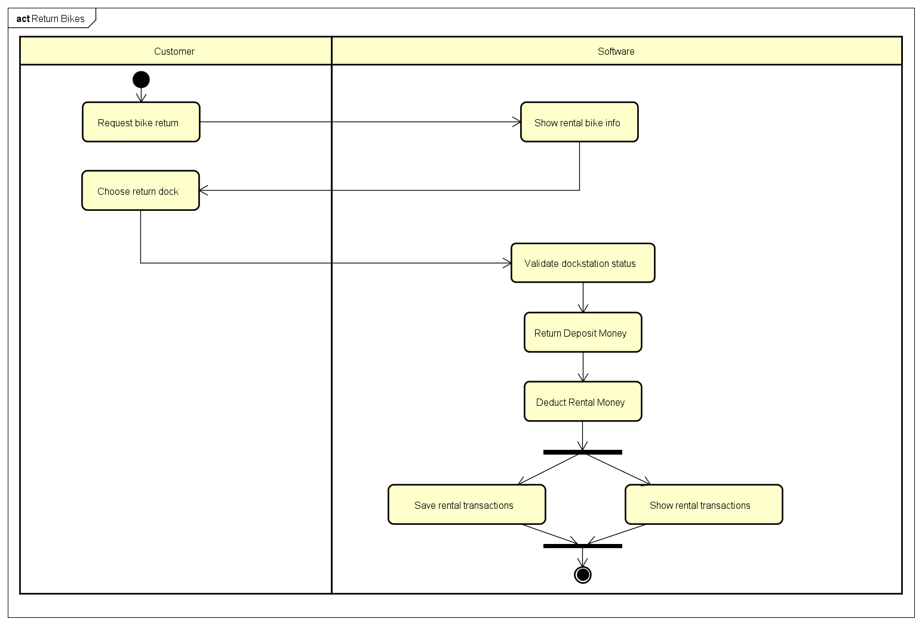

### 3.4.8. Input data

Table A- Input data for Barcode Scanning

|  |  |  |  |  |  |
| --- | --- | --- | --- | --- | --- |
| **No** | **Data fields** | **Description** | **Mandatory** | **Valid condition** | **Example** |
| 1. 1 | Barcode number | Barcode of the rented bike | Yes |  | 3jk6ad2 |

### 3.4.9. Output data

Table B- Output data for Barcode Scanning

|  |  |  |  |  |
| --- | --- | --- | --- | --- |
| **No** | **Data fields** | **Description** | **Display format** | **Example** |
| 1 | Customer name | The name of the customer |  | Vu Trung Dung |
| 2 | Barcode of the rented bike |  |  | 3jk6ad2 |
| 3 | Rented Bike Information | Information of rented bike |  | E-bike, Battery 80% |
| 4 | Deduct Amount | Total money for the rented bike | Comma for thousands separator  Have positive or negative sign  Right alignment | - 246,000 |
| 5 | Deposit Amount | Total money for depositing the bike | Comma for thousands separator  Have positive or negative sign  Right alignment | + 200,000 |
| 6 | Currency |  |  | VND |
| 8 | Subtotal | Total money the customer have to pay, include returned deposit amount | Comma for thousands separator  Have positive or negative sign  Right alignment | - 46,000 |
| 7 | Transaction status | The status of the transaction | Success - Failed | Success |

### 3.4.10. Postconditions

None

## 3.5. Use case specification for “Return Deposit Money”

### 3.5.1. Use case code

UC005

### 3.5.2. Brief Description

This Use case describes the interaction between Customer and EcoBikeRental System where Customers wish to take back the deposit money they had already deposited before.

### 3.5.3. Actors

* Customer
* Interbank

### 3.5.4. Preconditions

Customer had already deposit money for rented bike in EcoBikeRental System

### 3.5.5. Basic Flow of Events

Step 1. The Software calls Add API from the bank .

Step 2. The Interbank shows the card information of the customer.

Step 3. The Customer confirms that the card information is correct.

Step 4. The Interbank adds deposit money to customer’s credit card

Step 5. The Software displays the success transaction.

### 3.5.6. Alternative flows

Table N-Alternative flows of events for UC Return Bike

|  |  |  |  |  |
| --- | --- | --- | --- | --- |
| **No** | **Location** | **Condition** | **Action** | **Resume location** |
|  | At Step 3 | If the card information is invalid | * Software notifies that the interbank return the wrong card information | Resumes at Step 1 |

### 3.5.7. Activity diagrams

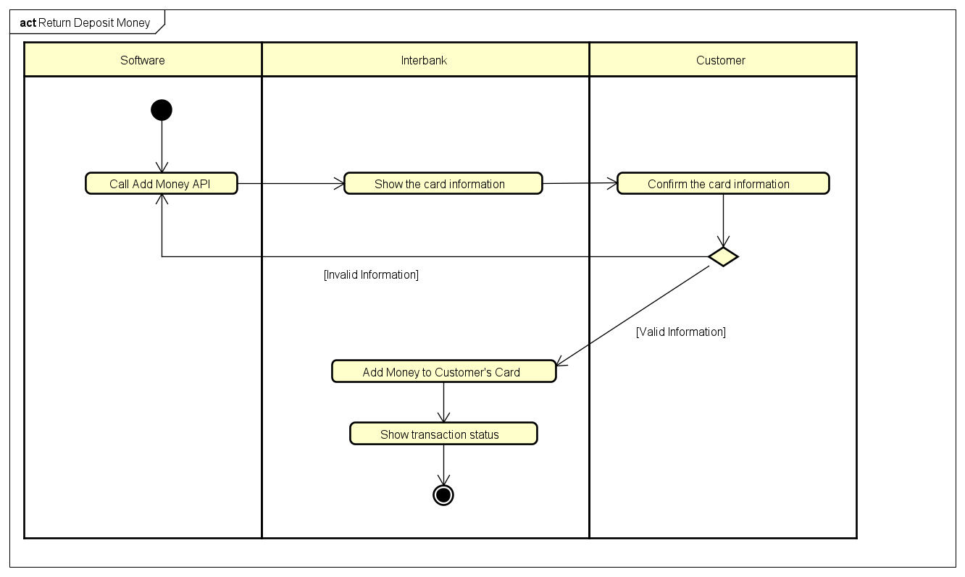

### 3.5.8. Input data

None

### 3.5.9. Output data

Table B1-Output data of Displaying card information

|  |  |  |  |  |
| --- | --- | --- | --- | --- |
| **No** | **Data fields** | **Description** | **Display format** | **Example** |
| 1 | Bank’s name | The name of the card’s bank |  | Techcombank Hang Dau |
| 2 | Card’s information | Information of the card holder, includes card number and card holder’s name |  | 1902470153012  Chu Viet Dung |

Table B2-Output data of Displaying transactions status

|  |  |  |  |  |
| --- | --- | --- | --- | --- |
| **No** | **Data fields** | **Description** | **Display format** | **Example** |
| 1 | Bank’s name | The name of the card’s bank |  | Techcombank Hang Dau |
| 2 | Card’s information | Information of the card holder, includes card number and card holder’s name |  | 1902470153012  Chu Viet Dung |
| 4 | Return Deposit Amount | Total deposit money to be returned | Comma for thousands separator  Positive integer  Right alignment | 200,000 |
| 5 | Currency |  |  | VND |
| 6 | Transaction status | The status of the transaction | Success - Failed | Success |
| 8 | Transaction instructions |  |  | Return Deposit Money for Bike rented in EcoBikeRental System |

### 3.5.10. Postconditions

None

## 3.6. Use case specification for “View Rented Bikes Information”

### 3.6.1. Use case code

UC006

### 3.6.2. Brief Description

UC “View Rented Bike Information” allows users to see all the information of each bike they’re renting, including bike type, renting time, the amount to be paid up to now, and bike status (e.g current battery percentage of e-bike).

### 3.6.3. Actors

Customer

### 3.6.4. Preconditions

Successfully login

### 3.6.5. Basic Flow of Events

Step 1: Customer click on View Rented Bike tab

Step 2: Software check the user’s rental code and collect the bike information

Step 3: Software display the view of bike information currently rented by the user

### 3.6.6. Alternative flows

Table N-Alternative flows of events for UC View Bike Information

|  |  |  |  |  |
| --- | --- | --- | --- | --- |
| **No** | **Location** | **Condition** | **Action** | **Resume location** |
|  | At Step 2 | in case of failed querying, notify to the user, end of use case | * The software notify for the error to the user | The use case ends |

### 3.6.7. Activity diagrams

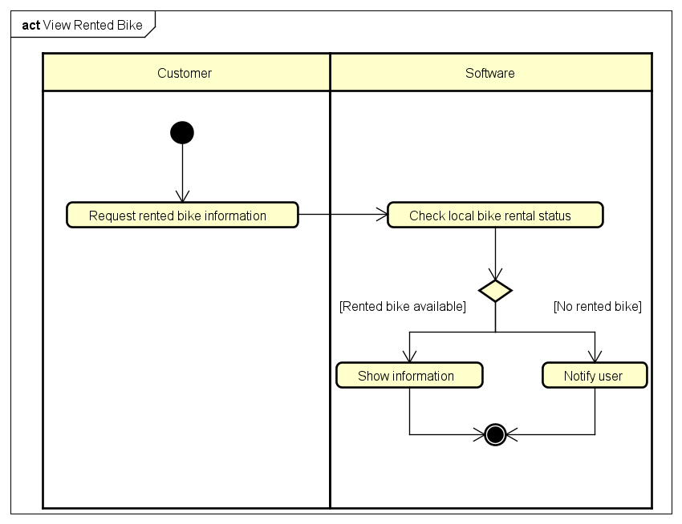

### 3.6.8. Input data

Table A- Input data for View Rented Bike Information

|  |  |  |  |  |  |
| --- | --- | --- | --- | --- | --- |
| **No** | **Data fields** | **Description** | **Mandatory** | **Valid condition** | **Example** |
| 1. 1. | Rental Code | Stored rental code on rented bike | Yes |  |  |

### 3.6.9. Output data

Table B- Output data for View Rented Bike Information

|  |  |  |  |  |
| --- | --- | --- | --- | --- |
| **No** | **Data fields** | **Description** | **Display format** | **Example** |
| 1 | Bike type | Type | Code | 1/2/3 |
| 2 | Renting time | Renting time | Time | 24m42s |
| 3 | Deposited amount | Money | Currency | 200000 VND |
| 4 | Current amount to be paid | Money | Currency | 15000 VND |

### 3.6.10. Postconditions

None

## 3.7. Use case specification for “View All Bikes In Station”

### 3.7.1. Use case code

UC007

### 3.7.2. Brief Description

UC “View All Bike in Station” allows the user to see all the bike in a specified station including: the bike category, the battery of e-bikes and availability status

### 3.7.3. Actors

* Customer

### 3.7.4. Preconditions

Successfully login

### 3.7.5. Basic Flow of Events

Step 1: Customer click on a dock to see information of bikes in that station

Step 2: Software check the station code from that click and collect the information in database

Step 3: Software display the view of available bike in a list/table for customer to choose

### 3.7.6. Alternative flows

Table N-Alternative flows of events for UC View Bike Information

|  |  |  |  |  |
| --- | --- | --- | --- | --- |
| **No** | **Location** | **Condition** | **Action** | **Resume location** |
|  | At Step 2 | in case of failed querying, notify to the user, end of use case | * The software notify for the error to the user | The use case ends |

### 3.7.7. Activity diagrams

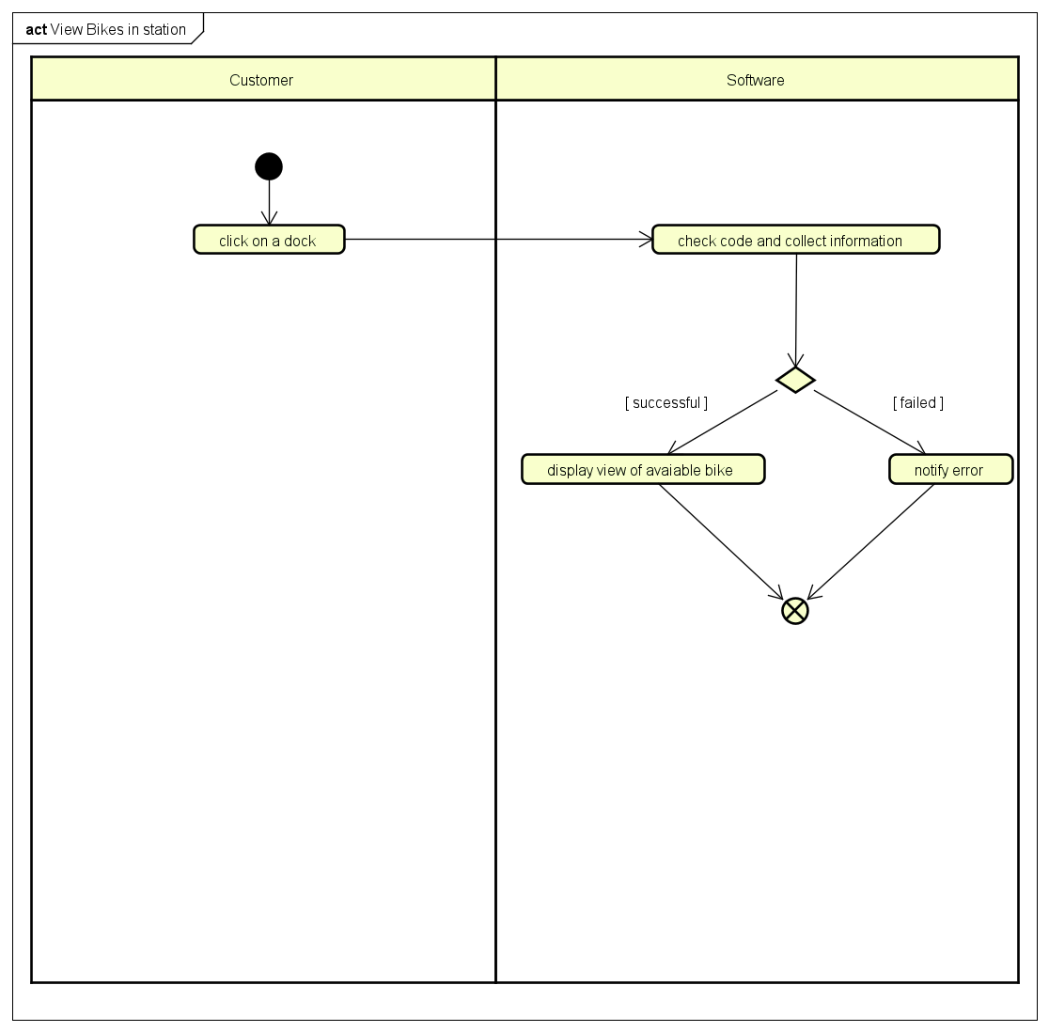

### 3.7.8. Input data

Table A- Input data for View Bike In Station

|  |  |  |  |  |  |
| --- | --- | --- | --- | --- | --- |
| **No** | **Data fields** | **Description** | **Mandatory** | **Valid condition** | **Example** |
| 1. 1. | Station code | Choose by clicking | Yes |  | Station1 |

### 3.7.9. Output data

Table B- Output data for View Bike In Station

|  |  |  |  |  |
| --- | --- | --- | --- | --- |
| **No** | **Data fields** | **Description** | **Display format** | **Example** |
| 1 | Type | Bike’s type | * Word | Standard |
| 2 | Battery | Current amount of battery (e-bikes) | * Percentage | 58% |
| 3 | Status | Bike’s availability | * Word | In Used |

### 3.7.10. Postconditions

Being able to choose and view details

## 3.8. Use case specification for “View Bike Details”

### 3.8.1. Use case code

UC008

### 3.8.2. Brief Description

UC “View Bike Details” allows the user to see all detailed information of each bike in a specified station including: the battery of e-bikes and the maximum amount of time that customer is able to use.

### 3.8.3. Actors

* Customer

### 3.8.4. Preconditions

Selected a bike from the bike list in each docking station

### 3.8.5. Basic Flow of Events

Step 1: Customer click on a bike to see detailed information

Step 2: Software get the detailed information from database query

Step 3: Software display the detailed information to the customer and provider renting bike option if possible

### 3.8.6. Alternative flows

Table N-Alternative flows of events for UC View Bike Details

|  |  |  |  |  |
| --- | --- | --- | --- | --- |
| **No** | **Location** | **Condition** | **Action** | **Resume location** |
|  | At Step 2 | in case of failed querying, notify to the user, end of use case | * The software notify for the error to the user | The use case ends |

### 3.8.7. Activity diagrams

### 3.8.8. Input data

Table A- Input data for View Bike Details

|  |  |  |  |  |  |
| --- | --- | --- | --- | --- | --- |
| **No** | **Data fields** | **Description** | **Mandatory** | **Valid condition** | **Example** |
| 1. 1. | Bike code | Choose by clicking | Yes |  | Bike1 |

### 3.8.9. Output data

Table B- Output data for View Bike Details

|  |  |  |  |  |
| --- | --- | --- | --- | --- |
| **No** | **Data fields** | **Description** | **Display format** | **Example** |
| 1 | Type | Bike’s type | * Word | Standard |
| 2 | Battery | Current amount of battery (e-bikes) | * Percentage | 58% |
| 3 | Color | Bike’s color | * Color | Blue |
| 4 | Barcode | Bike’s barcode | * Numbers | #12424 |
| 5 | Value | Bike’s value | * Numbers | 40000 VND |
| 6 | Deposit Charges | All of bike’s different deposit charges | * Numbers | 3000 VND |

### 3.8.10. Postconditions

Being able to choose renting option

## 3.9. Use case specification for “View All Dock Stations”

### 3.9.1. Use case code

UC009

### 3.9.2. Brief Description

UC “View All Dock Station” allows the user to see all the available dock stations along with their details like location, area size and number of bikes available in each dock

### 3.9.3. Actors

* Customer

### 3.9.4. Preconditions

Successfully login

### 3.9.5. Basic Flow of Events

Step 1: Customer start the app

Step 2: Software check the collect the information in database

Step 3: Software display the list of available dock stations in a list for customer to choose

### 3.9.6. Alternative flows

Table N-Alternative flows of events for UC View All Dock Station

|  |  |  |  |  |
| --- | --- | --- | --- | --- |
| **No** | **Location** | **Condition** | **Action** | **Resume location** |
|  | At Step 2 | in case of failed querying, notify to the user, end of use case | * The software notify for the error to the user | The use case ends |

### 3.9.7. Activity diagrams

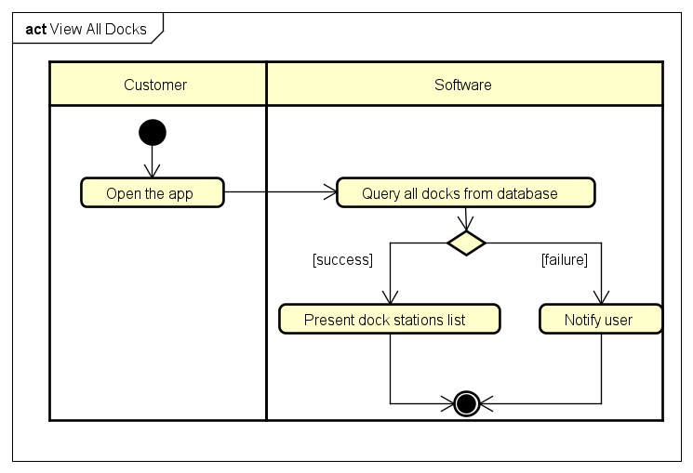

### 3.9.8. Input data

None

### 3.9.9. Output data

Table B- Output data for View Bike In Station

|  |  |  |  |  |
| --- | --- | --- | --- | --- |
| **No** | **Data fields** | **Description** | **Display format** | **Example** |
| 1 | Name | Dock’s name | * Words | Thanh Xuan |
| 2 | Address | Dock’s address | * Numbers and words | Hanoi |
| 3 | Area | Dock’s area size | * Number | 252x252 |
| 4 | Available bike | Number of available bikes in dock | * Number | 3//30 |

### 3.9.10. Postconditions

Being able to choose a bike

# Supplementary specification

## 4.1. Functionality

* EcoBikeRental System allows Customers to use the System for their need to rent bikes.
* EcoBikeRental System allows Customers to choose credit cards from different banks to pay for their renting charge.
* Platform of using: Website

## 4.2. Usability

* The software doesn’t require any specific skill to use and is appropriate for all ages.
* The GUI is totally clear and responsive for web app or mobile app so that the users don’t have any problem in seeing the desired result

## 4.3. Reliability

* Mean time between failures is roughly 1 year
* Mean time to repair is 24 hours
* There are critical errors such as database crash or heavy traffic

## 4.4. Performance

* The average response time is 3 second after users perform an action to a software feature. There are notifications in case the system has errors or crashes.

## 4.5. Supportability

* The software can be accessed and installed only through android system/ website

## 4.6. Other requirements

None